

**LAB#07**

**APPLIED PHYSICS LAB**

**Submitted to :Mr.Muhammad Shoaib**

**Submitted by: Group Of**

**Laraib Ijaz (2021-BSE-036)**

**Fizza Khan (2021-BSE-012)**

**Tanzeela Asgher(2021-BSE-032)**

**Date : 19th Feb,2022**

**TOPIC:HALF WAVE RECTIFICATION**

**Procedure:**

1. We took diode and resistor and connect them in series with functIon generator as shown below.

2. Wave form is observed by connecting the probe with an oscilloscope and circuit.

3. Waveform obtained was observed.

4. Experiment was performed for both positive and negative half wave’s rectification.

**Positive wave-form:**

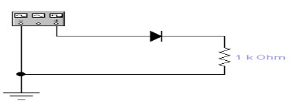

**Observations:**

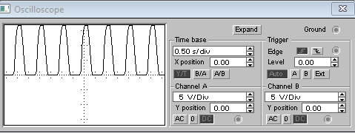

**Negative wave-form:**

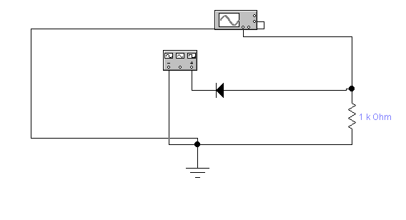

**Observations:**

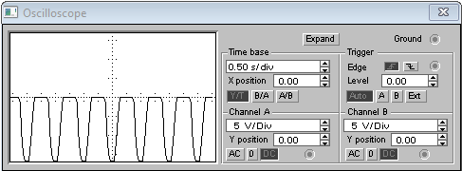

**Waves with voltage source in circuit**

1. We took the diode, AC voltage source and resistor and connected them in series with functIon generator as shown below.

2. Wave form is observed by connecting the probe with an oscilloscope and circuit.

3. Waveform obtained was observed.

4. Experiment was performed for both positive and negative half wave’s rectification.

**Positive wave-form:**

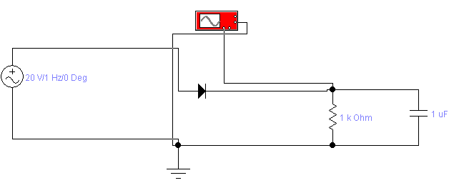

**Observations:**

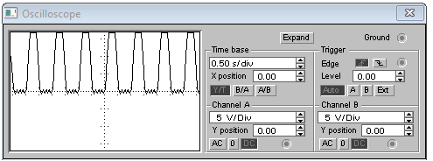

**Negative wave-form:**

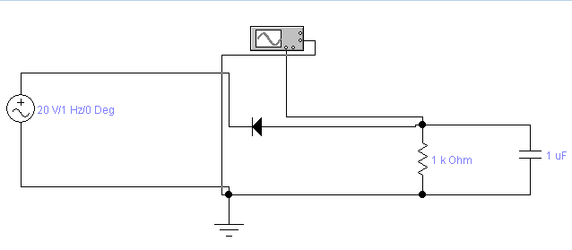

**Observations:**

